Practical - 9
Practical Title: Secure User Registration with Database Insert, Duplicate Email Check, and Password Hashing

Problem Definition: Implement secure user registration by inserting user details into MySQL using MYSQLi. Validate input on frontend and backend, check duplicate email/username, hash passwords using password_hash(), and display appropriate messages.

Theory

Is password_hash() used before storing passwords?
Answer: Yes, password_hash($password, PASSWORD_DEFAULT) hashes passwords before SQL insertion.

Is duplicate email/username checked?
Answer: Yes, a prepared SELECT query checks for existing emails before inserting.

3. Are frontend and backend validations consistent?
Answer: Yes, required fields, email formats, and password lengths match across JS and PHP.

Implementation/ Output/Result
Feature | Implementation
Database Connection | MySQLi object (new mysqli())
Validation | Frontend (JS/HTML) and backend (filter_var, empty())
Duplicate email check | MySQLi prepared statement (SELECT student_id ... WHERE email = ?)
Password Security | One-way BRYPT hashing using password_hash()
Data Insertion | Parameterized query via $stmt->bind_param() & execute()

Evidence of Work (Screenshots)
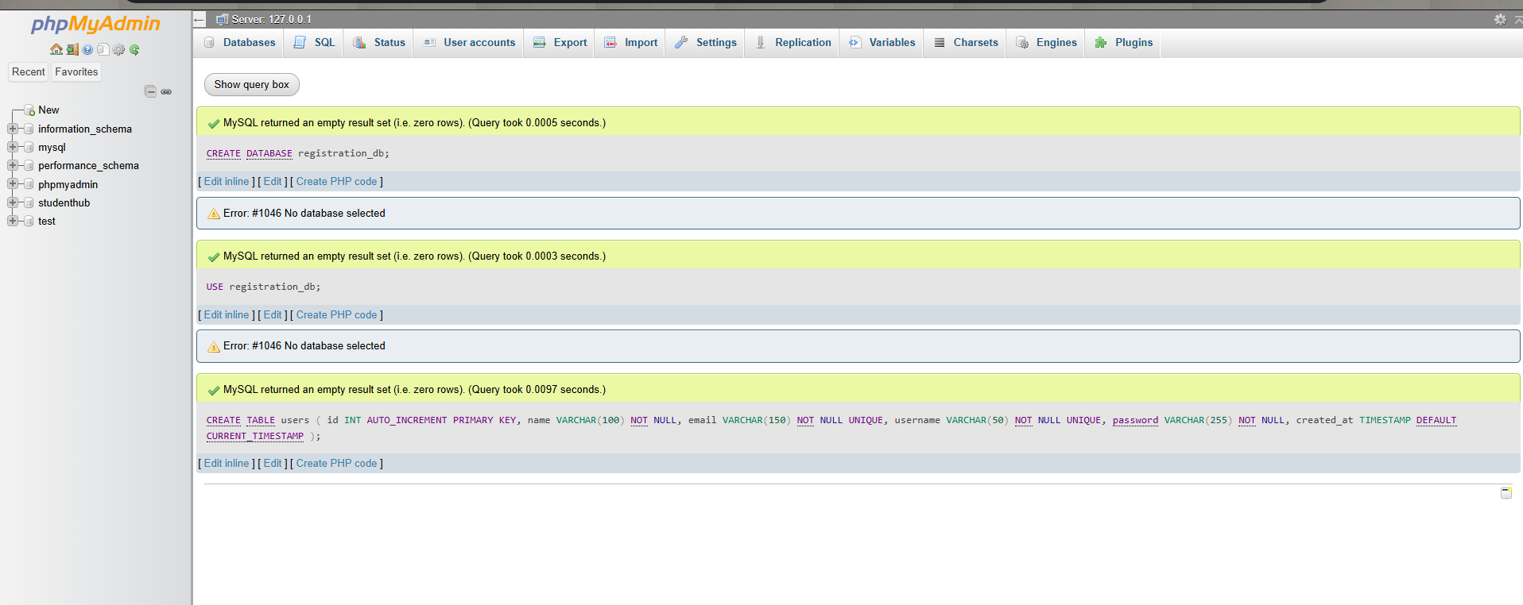
Description: Figure 9.1 registration success

GitHub Repository Link:
Link: https://github.com/meetp2m/WDF-PRACTICAL-9

Challenges Faced:
Handling duplicate email conditions while ensuring the password hash isn't truncated by an undersized database column.

Learning Outcome:
I learned how to implement secure user registration following basic web security practices.

Faculty Remarks:

